**Regents Questions:**

**Area of Sectors, Arc Lengths and Conversions of Degrees to Radians or Radians to Degrees**

1)

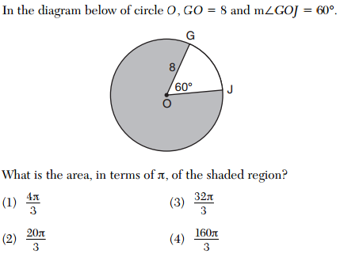

2)

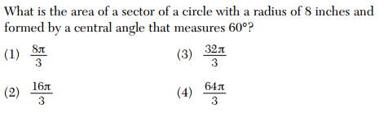

3)

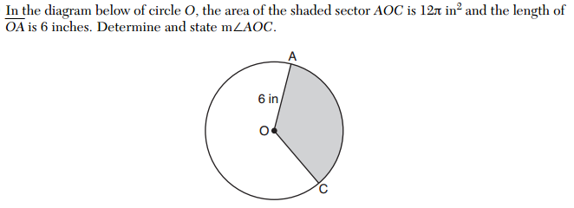

4)

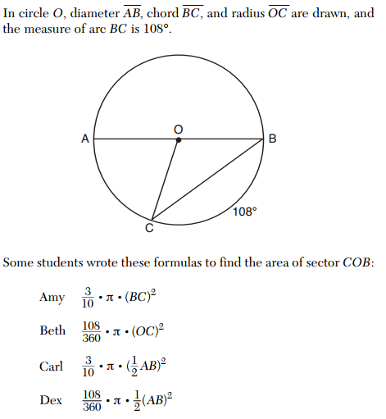

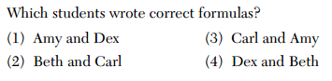

5)

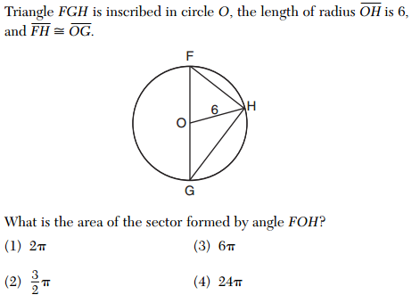

6)

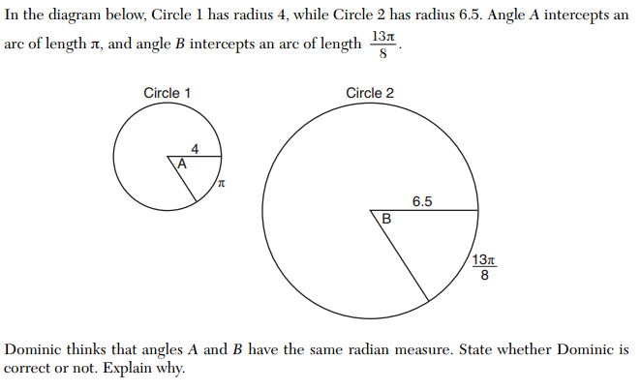

7)

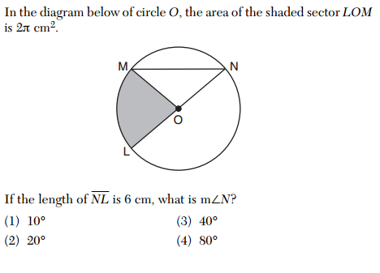

8)



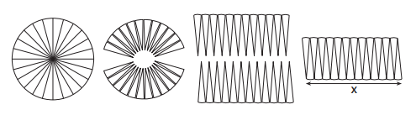

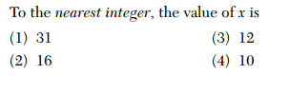

9)

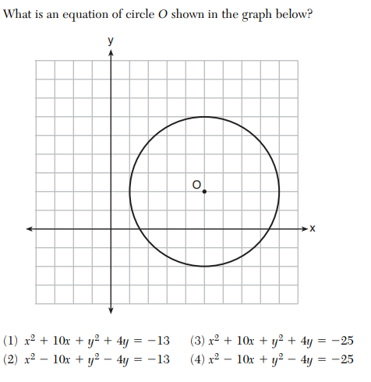

10)

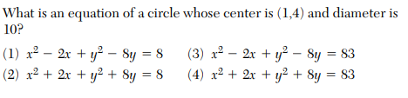

11) Use completing the square to identify the center and radius:

 C = ___________ R = ____________

12) A circle has a center at  and radius of 4. Does the point  lie on the circle? Algebraically justify your answer.

13) The center of circle *Q* has coordinates . If circle *Q* passes through , what is the equation of the circle?